MyMedicalHUB

***Release Note***

|  |  |
| --- | --- |
| Document Version: | 1.1 |
| Date of Document Version: | 22/07/2022 |
| Product Version: |  |
| Date of Product Version: |  |
| Created by: | Jannatul Fardus Liza |
| Reviewed by: | Shoriful Islam |
| Approved by: | Shoriful Islam |
| Confidentiality level: | High |

**Change History**

|  |  |  |  |
| --- | --- | --- | --- |
| **Date** | **Version** | **Created by** | **Description of change** |
| 22nd July 2022 | 1.1 | Jannatul Fardus Liza | Chief Complaints New Skeleton, Merged Exercise, New Skeleton on Pain Logs, Outcome Assessment on BOT and Patients Edit Assessment page |

**Table of Contents**

1. Introduction 4

2. Overview 4

3. Getting Started 4

*3.1 Patient Chief Complaints New Skeleton on BOT* 4

*3.2 Patient Chief Complaints New Skeleton on Edit Assessment Page* 5

*3.3 New Skeleton Chief Complaints Diagram on Patients Pain-log* 7

*3.4 Merged Exercise* 7

*3.5 Outcome Assessments in BOT* 9

# Introduction

This Release Note provides the information necessary for users to effectively use the System. This is a General Guideline. Any user can go through our system with this guideline. Here we have included all new features which have been implemented recently.

# Overview

Our System has 2 Portals

1. Provider
2. Patient

The Provider can do several Functionalities Like invite a Patient for Telemedicine, Self-Assessment, In Clinic Encounter, Pain log, Take Biometric Assessment, Put personal views on the Assessment Reports etc.

On the other hand, Patient can be registered to our system through the providers invitation. Patient can do self-assessment, Telemedicine, Follow-up etc. There are Some Other features as well included at Provider and Patient Portal.

For System improvements Some new feature and changed have been made. This Document has covered all the recent changes.

# Getting Started

The New features which have been implemented recently are given below:

## *3.1 Patient Chief Complaints New Skeleton on BOT*

A new Chief Complaints Skeleton has been added to BOT. This feature is added to make the Chief Complaints effective. The Chief Complaints Diagram is same for both Patient and Provider.

**Steps:**

1. Invite a Patient for Self / Telemedicine/ In clinic / Follow-up
2. Patient stats from the patient portal notification modal
3. Now after Completing Demographic, ADL and Medical History then Patient stats Chief Complaints
4. On Chief Complaints Page Patient can see the new Skeleton Diagram

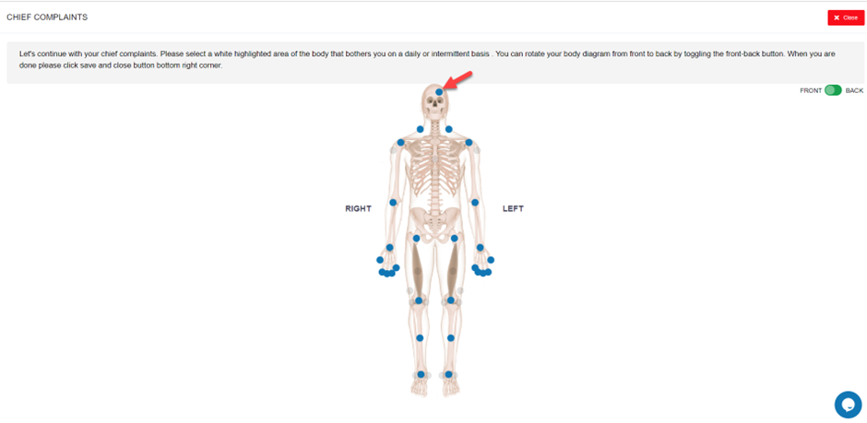

1. Now the user can select the Blue marked Circle and can answer all the questions.

## *3.2 Patient Chief Complaints New Skeleton on Edit Assessment Page*

From Edit Assessment Patient Can View the New Chief Complaints Diagram.

**Steps**:

1. Login to Patient Portal
2. Go to My Assessments
3. Then Click on Edit Button and go to Chief Complaints page

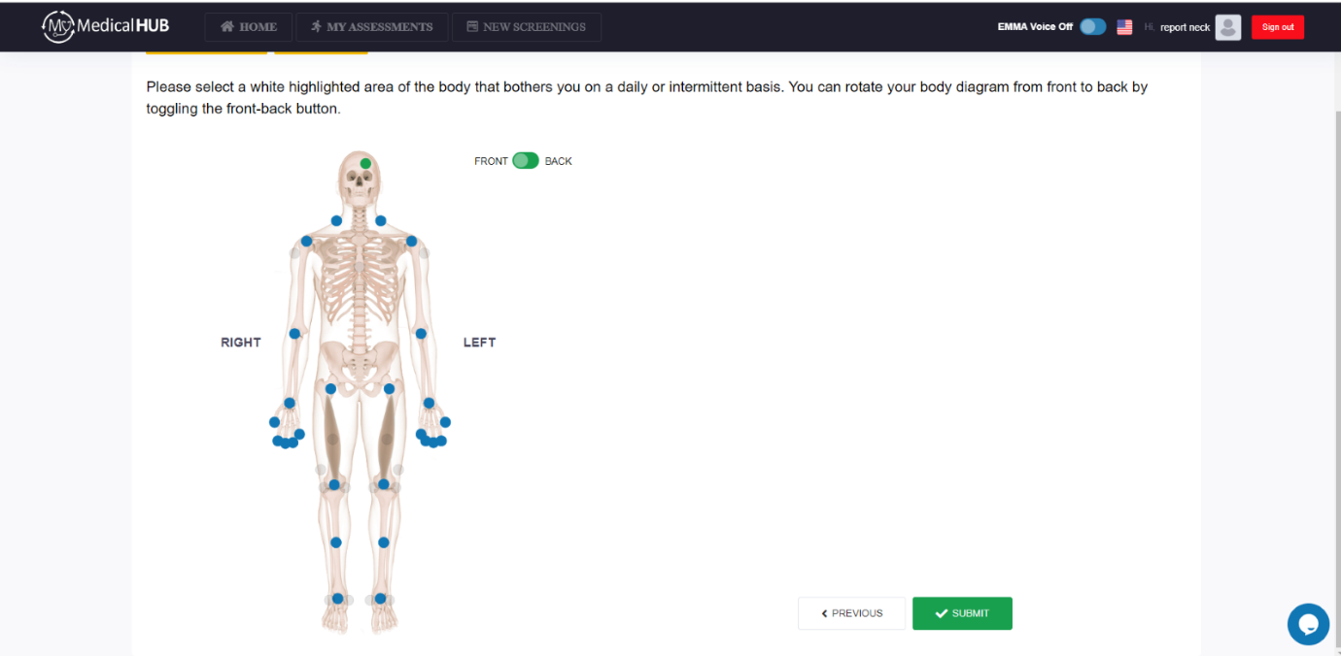

1. Now observe if patient give data for a particular body region from BOT it will highlighted and shows also from Edit Assessment page
2. From This page Patient can also add more data by selecting body regions.
3. If a patient selects a body region, then associated questions will appear

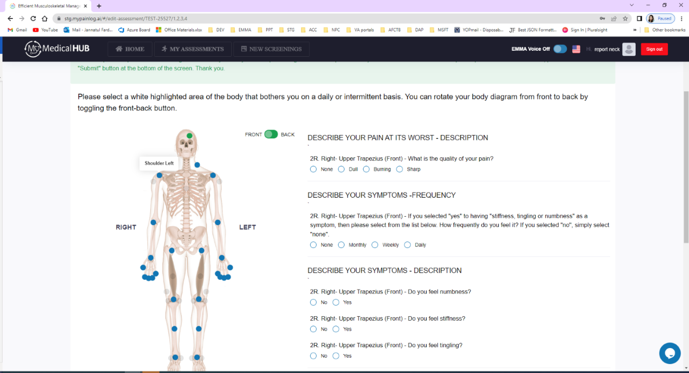

1. Patients have to answer all the questions and click on the SUBMIT button

## *3.3 New Skeleton Chief Complaints Diagram on Patients Pain-log*

The New Skeleton Body Diagram is also updated for Pain Log feature.

**Steps**:

1. Provider invites a patient for Pain log or patient can start Pain log bot from New Screening by clicking Pain Journal Virtual Assistant
2. Now start paint log bot and click Yes to question “Are you feeling any pain today?”
3. Observe the New Skeleton Chief Complaints Diagram is generated

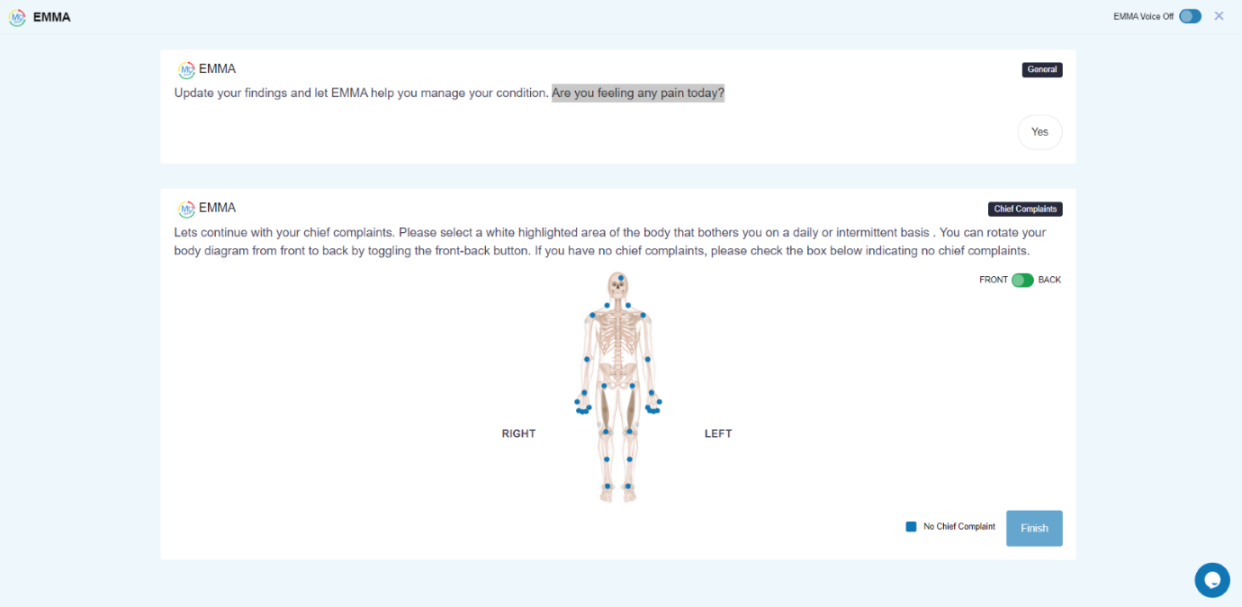

## *3.4 Merged Exercise*

Some Exercises are Merged together under Calibration. This feature is implemented to save time during Biometric Assessment.

**Merged Exercises Under Calibration**: Posture Front View, Trunk Left Lateral Bending - Start, Trunk Right Lateral Bending – Start , Fingers to Floor Biometric-Start

**Business Rules:**

* If Patient do Calibration all the merged Exercises will be start processing.
* When calibration Completed Merged Exercises will be Completed
* If Calibration gives Retake Merged Exercises will also give Retake
* If Calibration gives Human Expert Merged Exercises will also give Human Expert
* After Calibration Completed Only provider can Retake merged Exercises separately
* If Calibration status becomes Human Expert, Then Provider cannot Retake Merged Exercises Separately
* Provider can Review Annotation for Merged Exercises Separately
* Skipping the Merged Exercises is not possible
* All Merged Exercises will show Separately on Providers Report (HTML and PDF)

**Steps**:

1. Invite a Patient for Self / Telemedicine/ In clinic / Follow-up
2. Patient stats from the patient portal notification modal
3. Now after Completing Demographic, ADL and Medical History, Chief Complaints patient starts Biometric Movements
4. Now Start Calibration

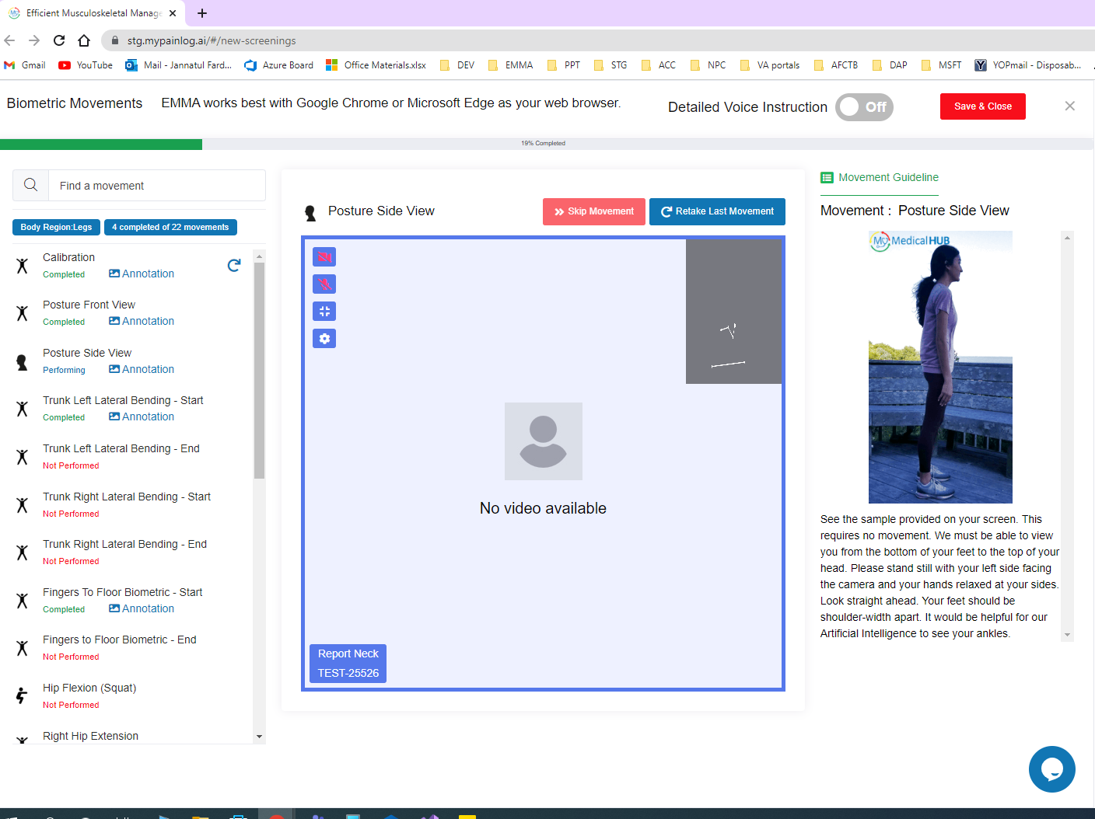

**5.** Now observe Calibration and it merged Exercises are Completed

## *3.5 Outcome Assessments in BOT*

**Business Rules:**

Outcome Assessment will be applicable for only Telemedicine

It will not come for Posture Assessment

Outcome Assessment will be generated after Chief Complaints on BOT

Is it possible to Review Outcome Assessment on BOT

Steps:

1. Provider invite a Telemedicine invitation to an old / New patient
2. Patient login to the patient portal and start the assessment
3. BOT started
4. Patient Now starts answering all section question
5. After Chief Complaints Outcome Assessment option generated

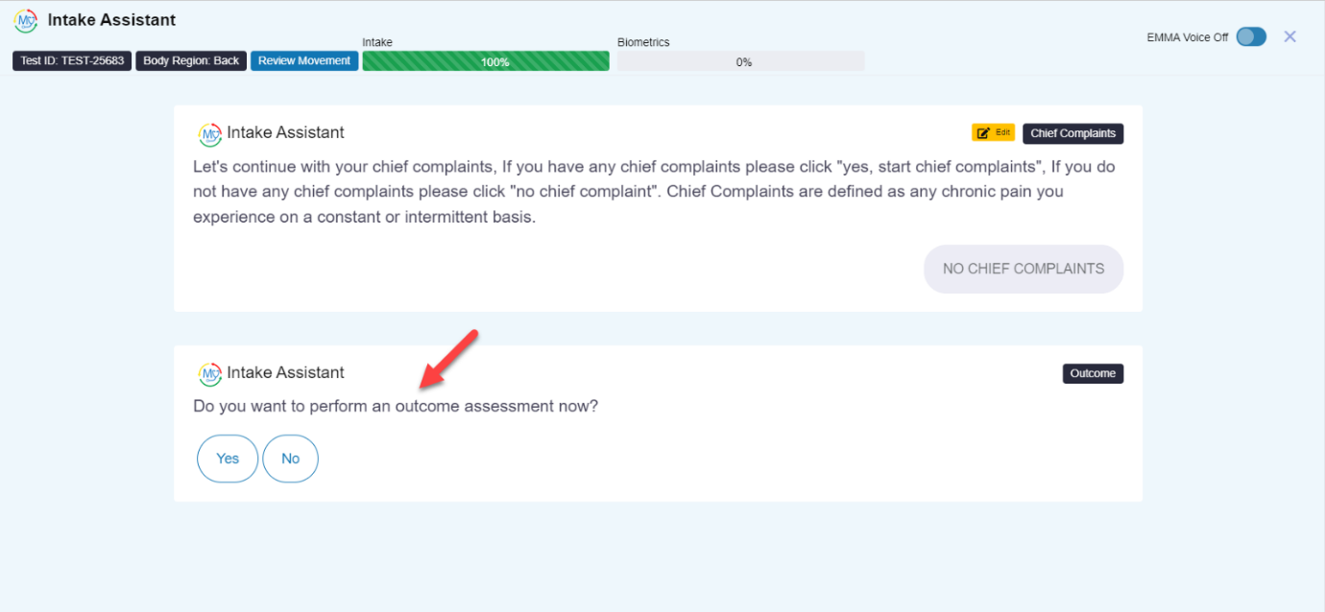

1. Now select Yes
2. Observe Body region related all outcome Assessment questions are generated

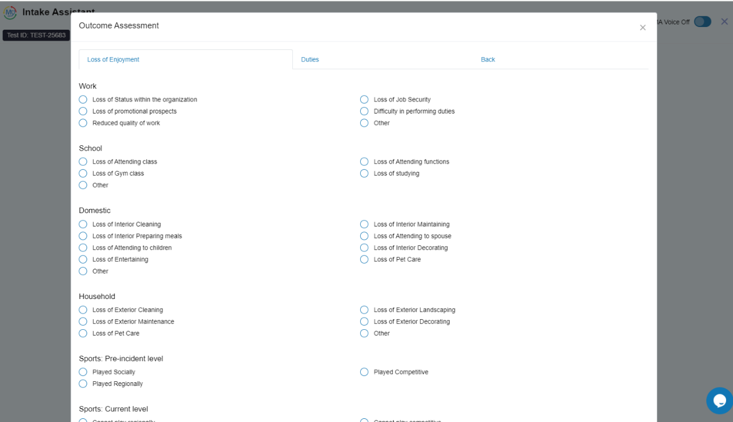

1. Then answer the questions
2. Now click on the Save button

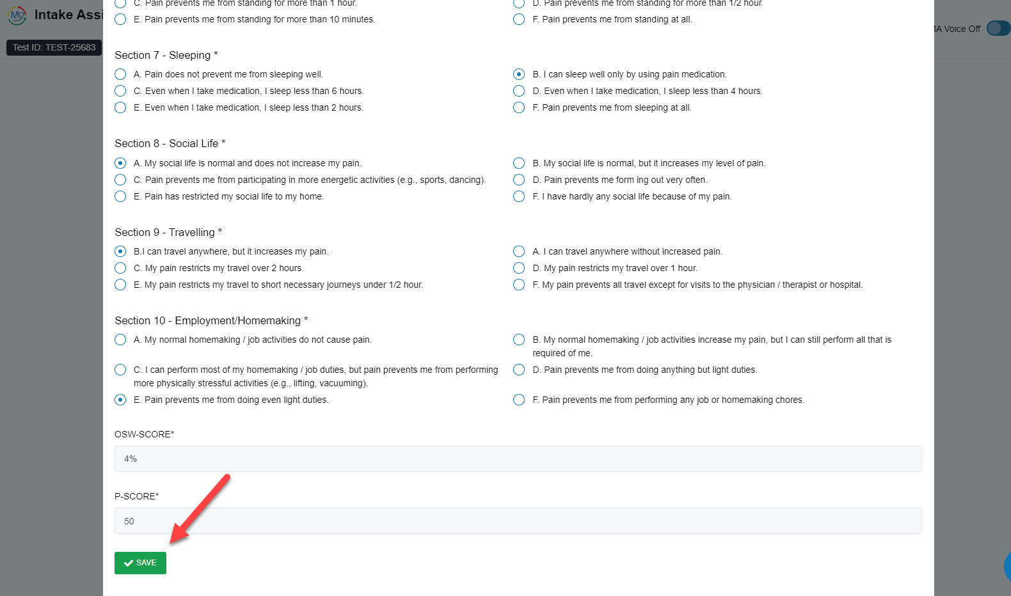

***3.6 Outcome Assessments on Patient Edit Assessment page***

**Steps:**

1. Go to My Assessment Page
2. Click on the Edit button for the particular test ID
3. Then open the body region tab where the outcome assessment questions are stored

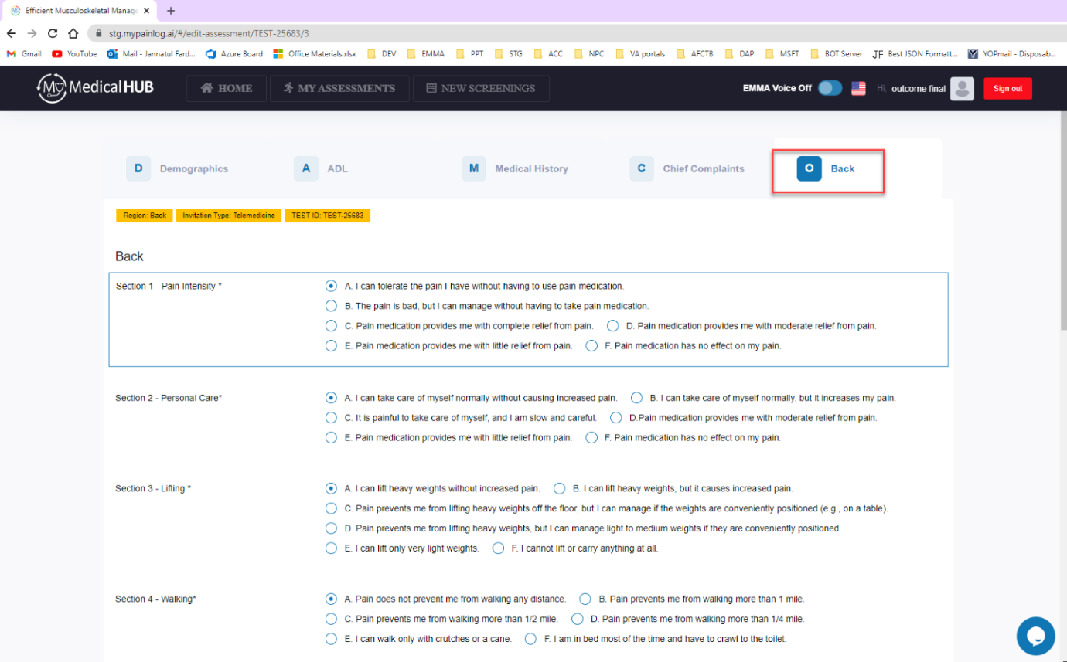

1. if patient wants to edit the outcome questions answer patient can do that
2. After editing click on the Submit button

